# **Automated Testing and Linux and Shell Scripting**

## 

## **Create a Directory Structure:**

**Objective:** Create a script that generates a specific directory structure under the ‘/home/user/’ directory.

Steps to Create the Script :

1. Create a New File: “touch create_structure.sh”

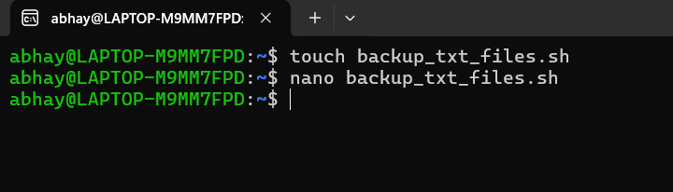

1. Write the Script in file: “nano create_structure.sh” and add this script -

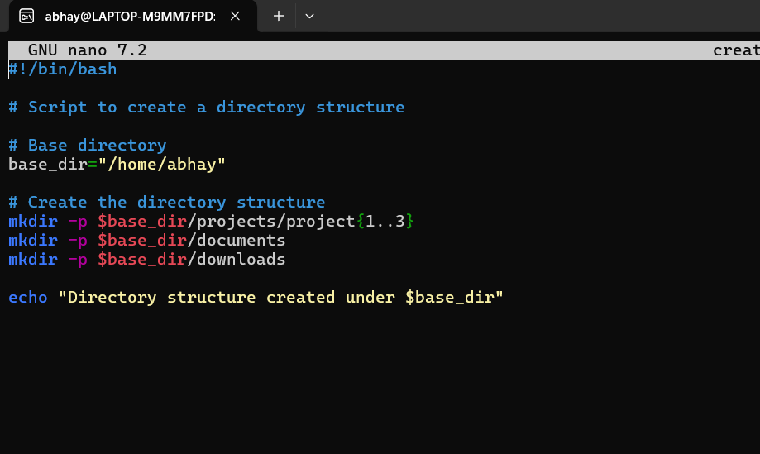

1. Save this script and make the script Executable: “chmod +x create_structure.sh”



1. Run the Script: “./create_structure.sh”

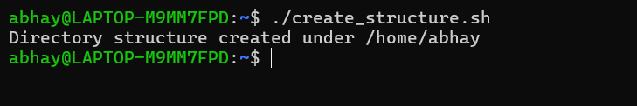

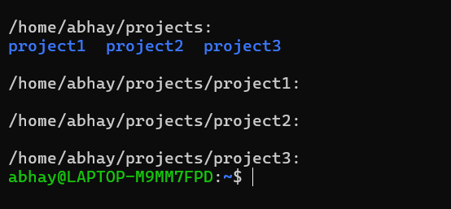

## **File Backup:**

1. Create a New File: “touch backup_txt_files.sh”



1. Write the Script: “nano backup_txt_files.sh”

Add following script:

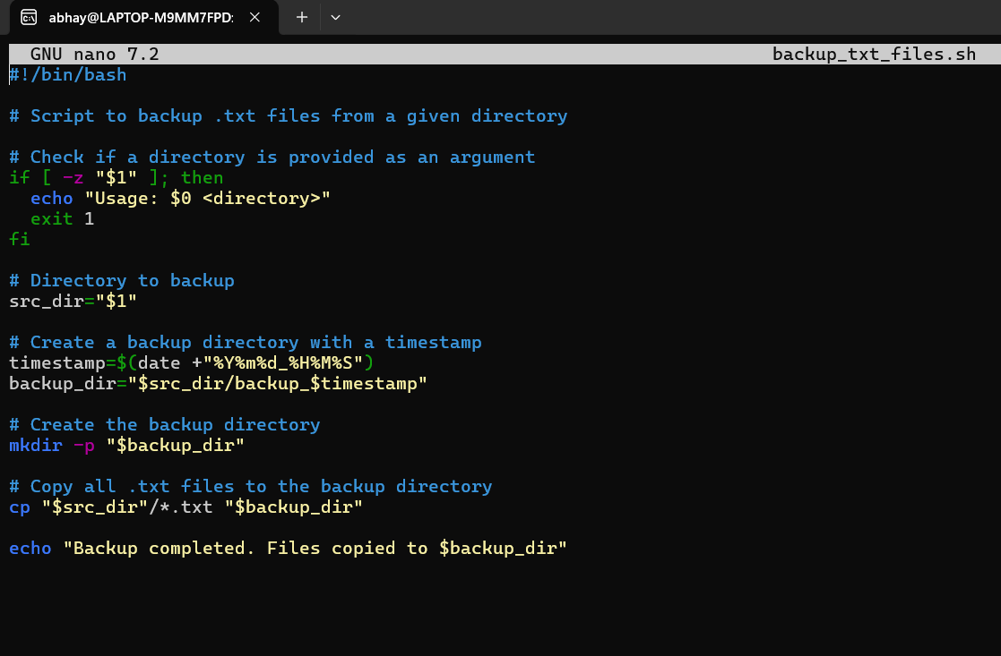

1. Create the Necessary Directory and Files:

Create ‘Document’ directory in my home directory and add ‘txt file in this directory’



1. Run the script:

“./backup_txt_files.sh ~/documents”



## **User Information Script:**

**Objective:** Create a script that displays the following information about the user:

Steps to Create the Script :

1. Create a new file : “touch user_info.sh”

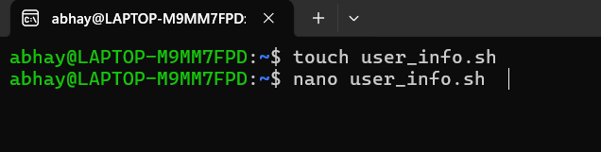

1. Write the Script in “user_info.sh” file :

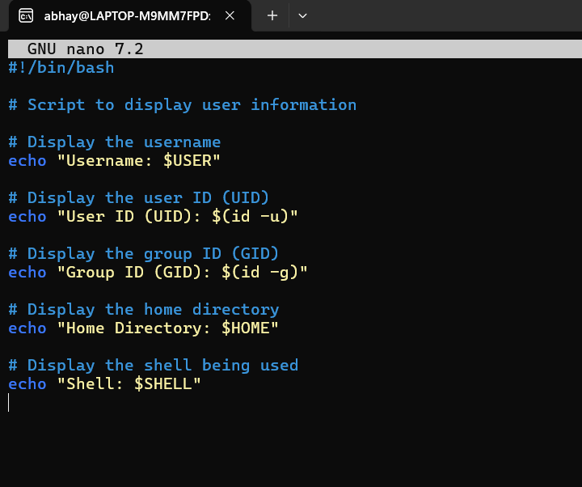

1. Make Executable Script : “chmod +x user_info.sh”
2. Run the Script ; “./user_info.sh”

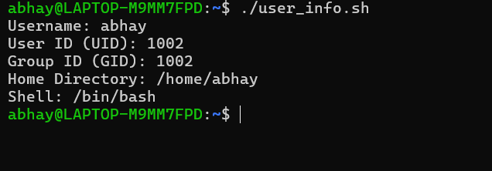

## **Disk Usage Alert Script:**

Steps to Create the Script

1. Create a New File: “touch disk_usage_alert.sh”

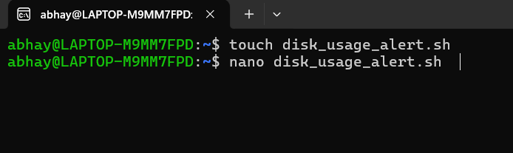

1. Write the script in file :

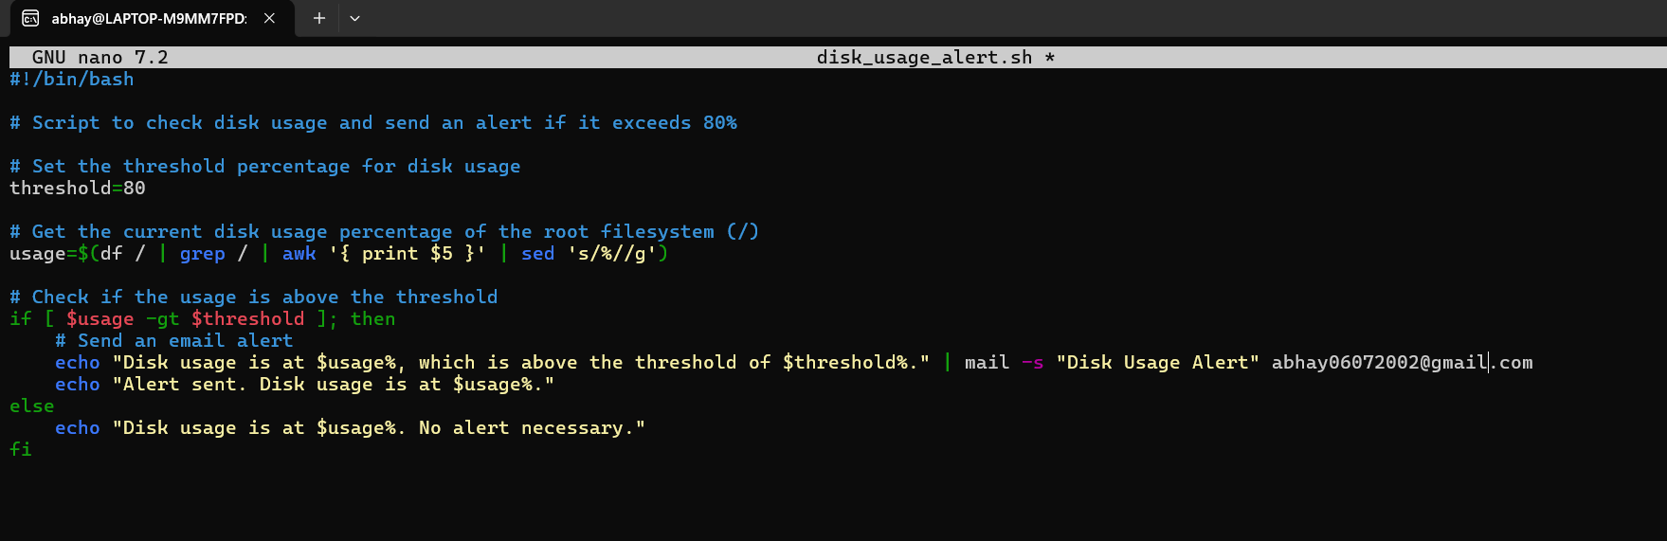

1. Make Script Executable : “chmod +x disk_usage_alert.sh”
2. Run the Script:

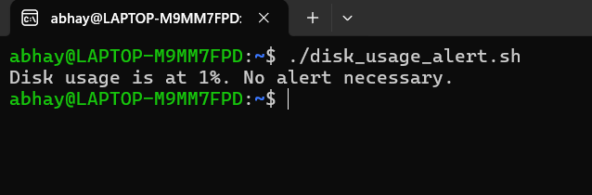

## **File Permission Checker Script:**

Steps to Create the Script

1. Create a New File: “touch file_permission_checker.sh”

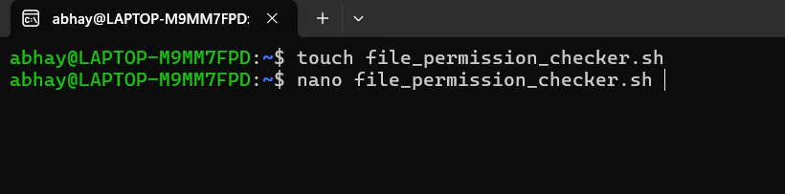

1. Write the Script in file

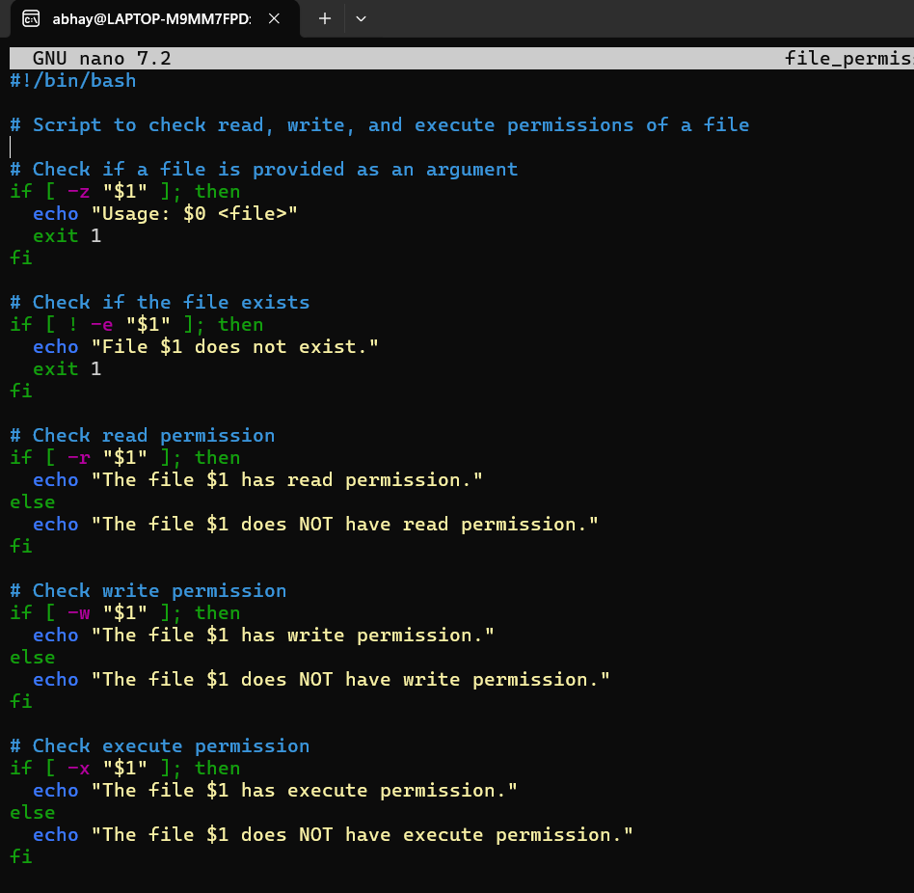

1. Make Script Executable: “chmod +x file_permission_checker.sh”
2. Test the Script: Create a sample file for testing

“touch sample_file.txt”

“chmod 644 sample_file.txt”



1. Run the script to check the permissions of ‘sample_file.txt’

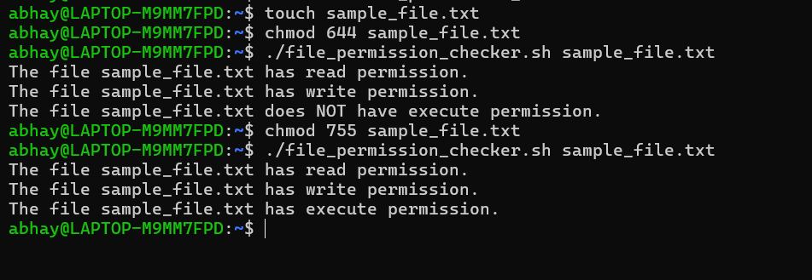

## **Automated Backup Script:**

Steps to Create the Script:

1. Create a new file “touch automated_backup.sh”

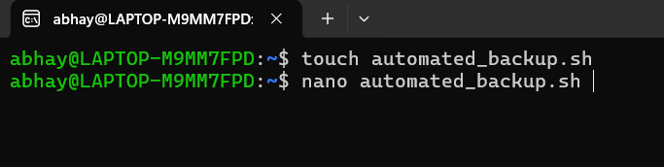

1. Write the Script in file :

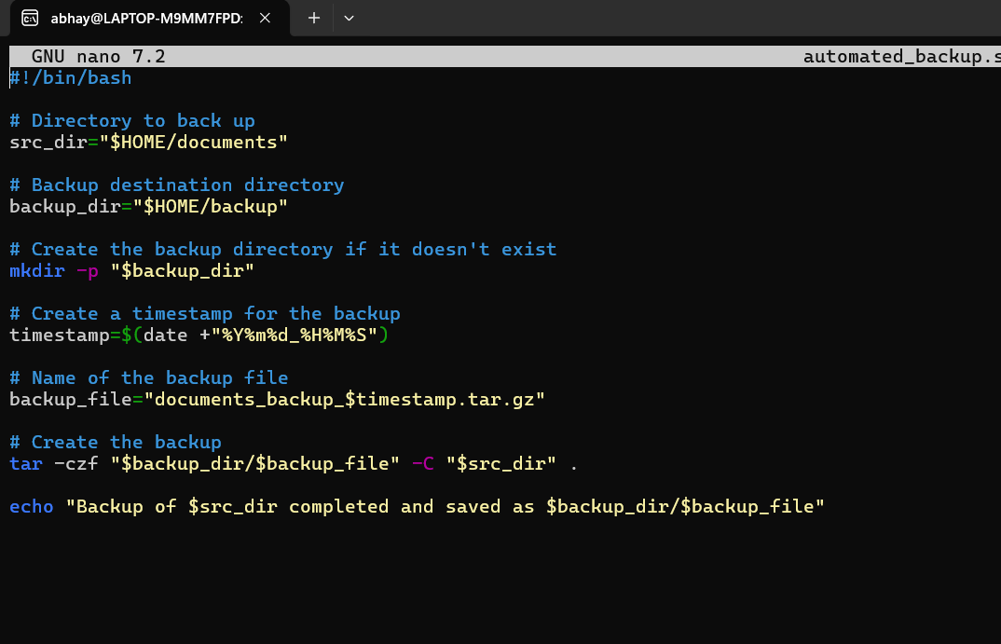

1. Make the Script Executable: “chmod +x automated_backup.sh”
2. Run the Script:



### scheduled to run daily using cron:

1. Edit Crontab: Open the crontab editor “crontab -e”
2. Add the Cron Job: “0 2 * * * /home/abhay/automated_backup.sh”

0 2 * * * means the script will run at 2:00 AM every day.

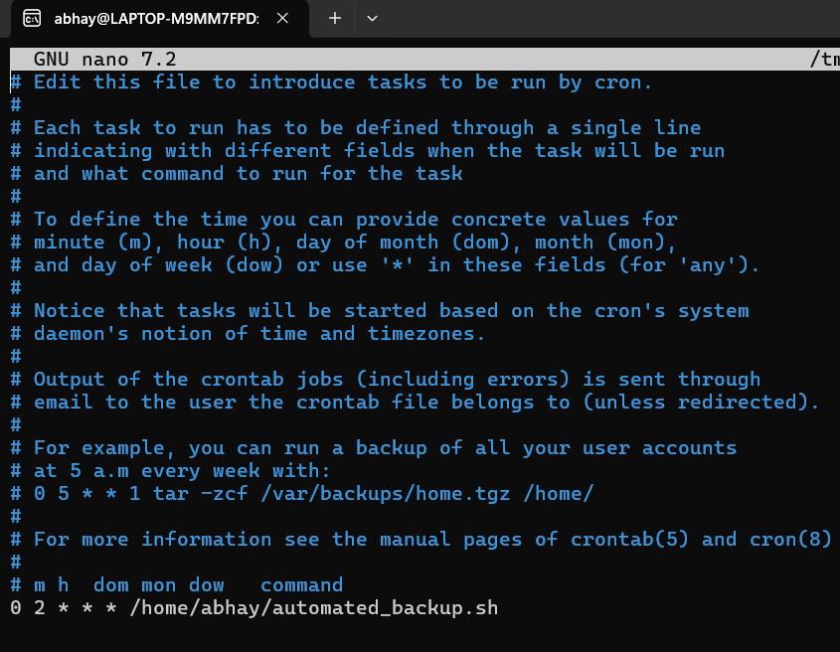

## **Process Monitor Script**:

Steps to create the script

1. Create a New Script File:

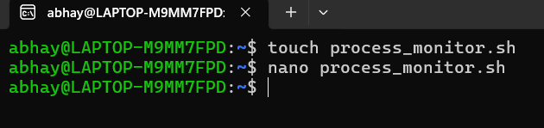

1. Write the Script in file:

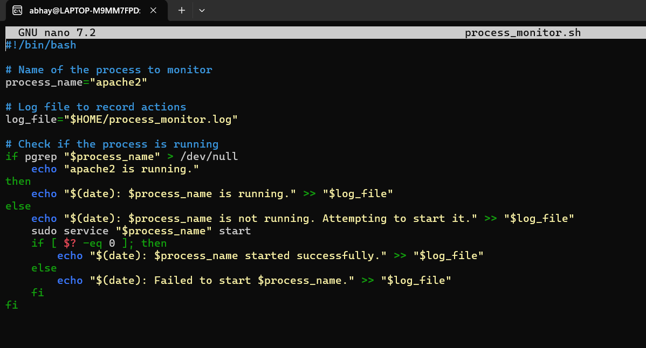

1. Make the Script Executable: “chmod +x process_monitor.sh”
2. Run the Script:
3. 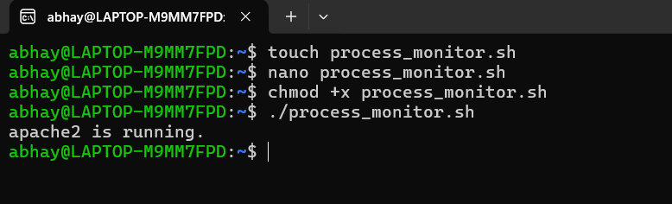

## **Text File Analysis:**

Steps to Create the Script

1. Create a .txt file for analysis: “nano sample_file.txt”

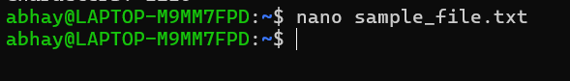

1. Write some line in the file:

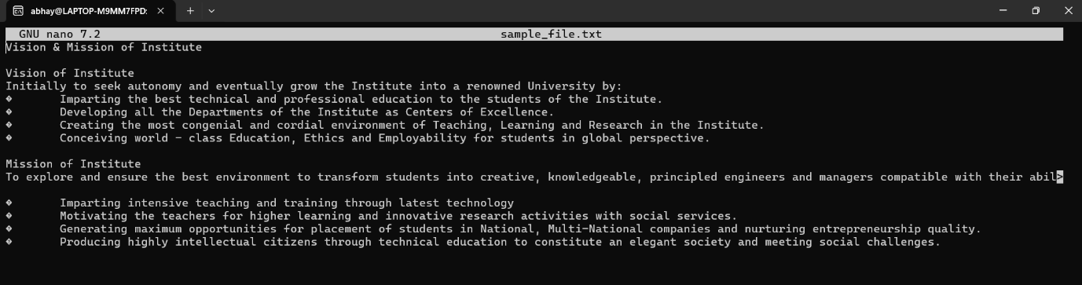

1. Create the Script File: “nano text_file_analysis.sh”

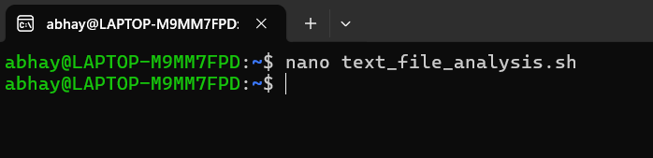

1. Write the Script in file:

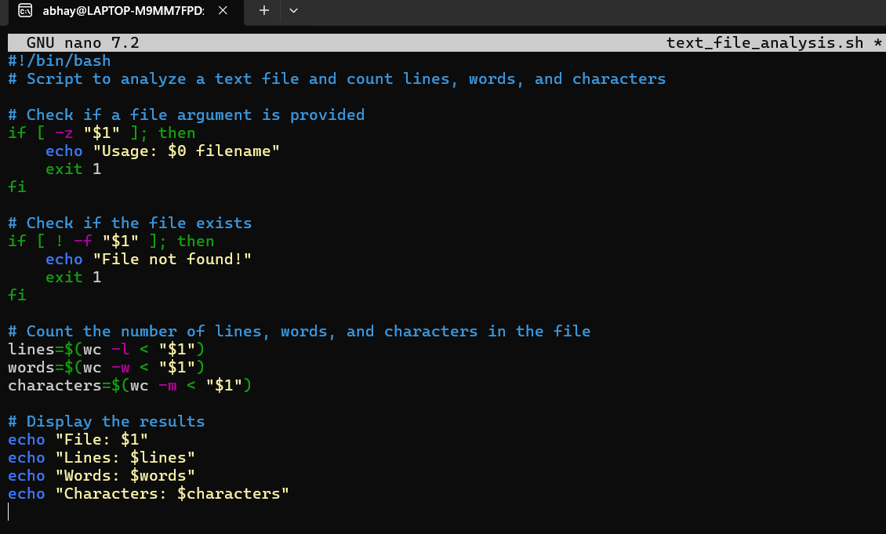

1. Make the Script Executable: “chmod +x text_file_analysis.sh”
2. Run the script:

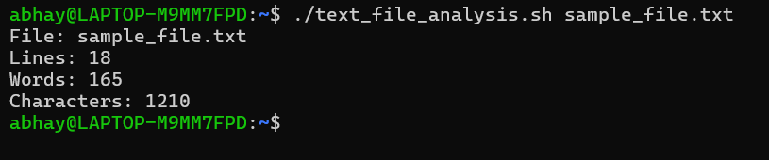

## **System Information Report:**

Steps to Create the Script:

1. Create the Script File:

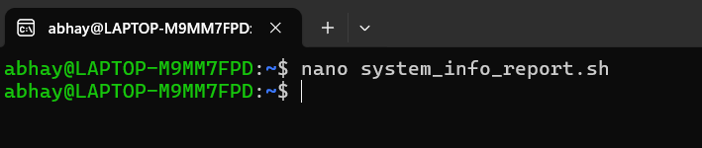

1. Write the Script in file:

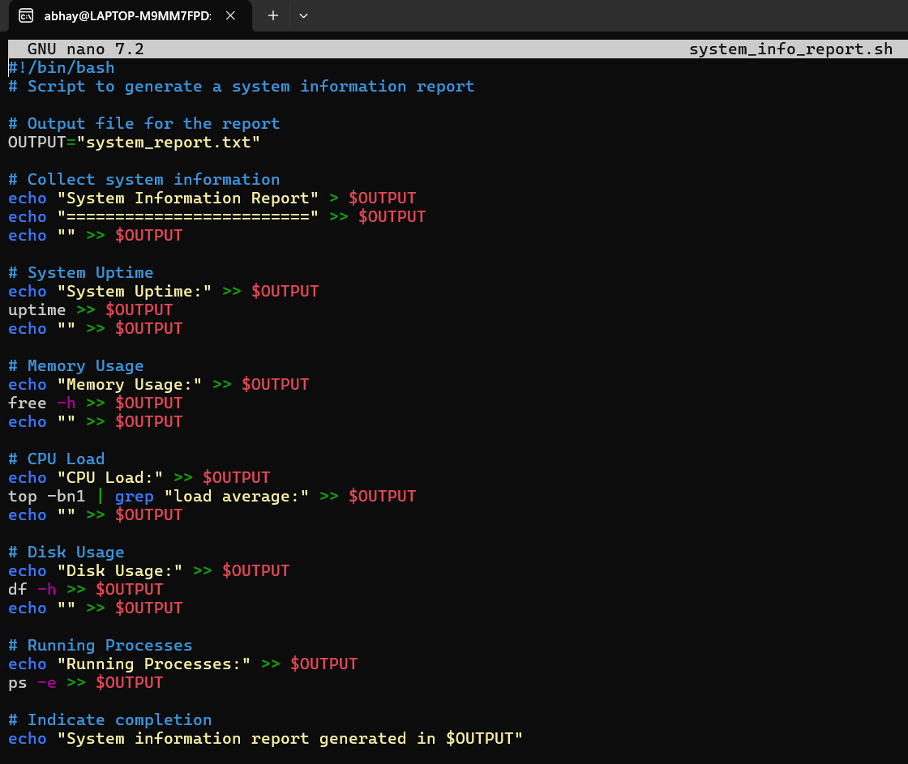

1. Make the Script Executable: “chmod +x system_info_report.sh”
2. Run the Script:

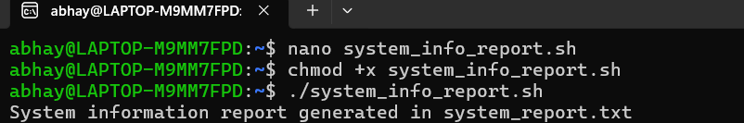

1. Check the Output:

After running the script, check the generated ‘system_report.txt’ file:

“cat system_report.txt”

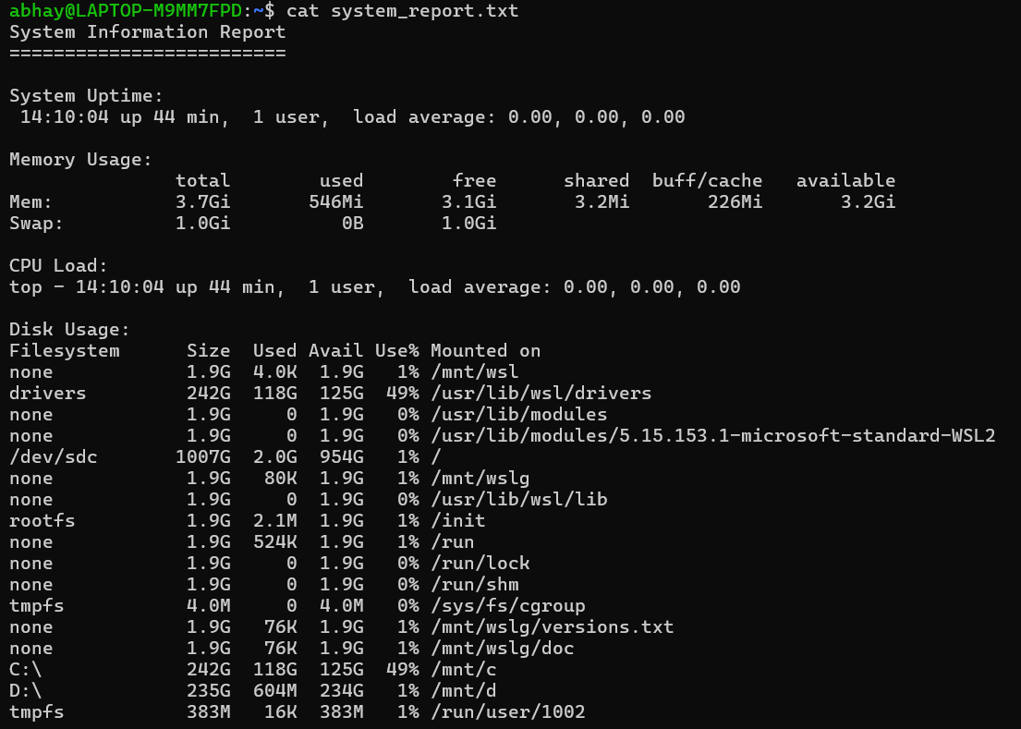

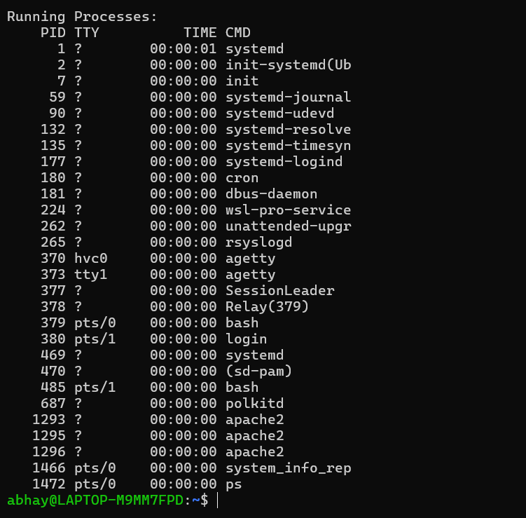

## **Simple Calculator:**

Steps to Create the Script:

1. Create the Script File:

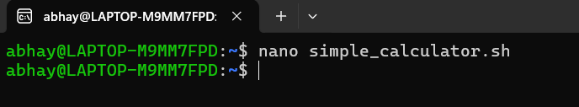

1. Write the Script in file:

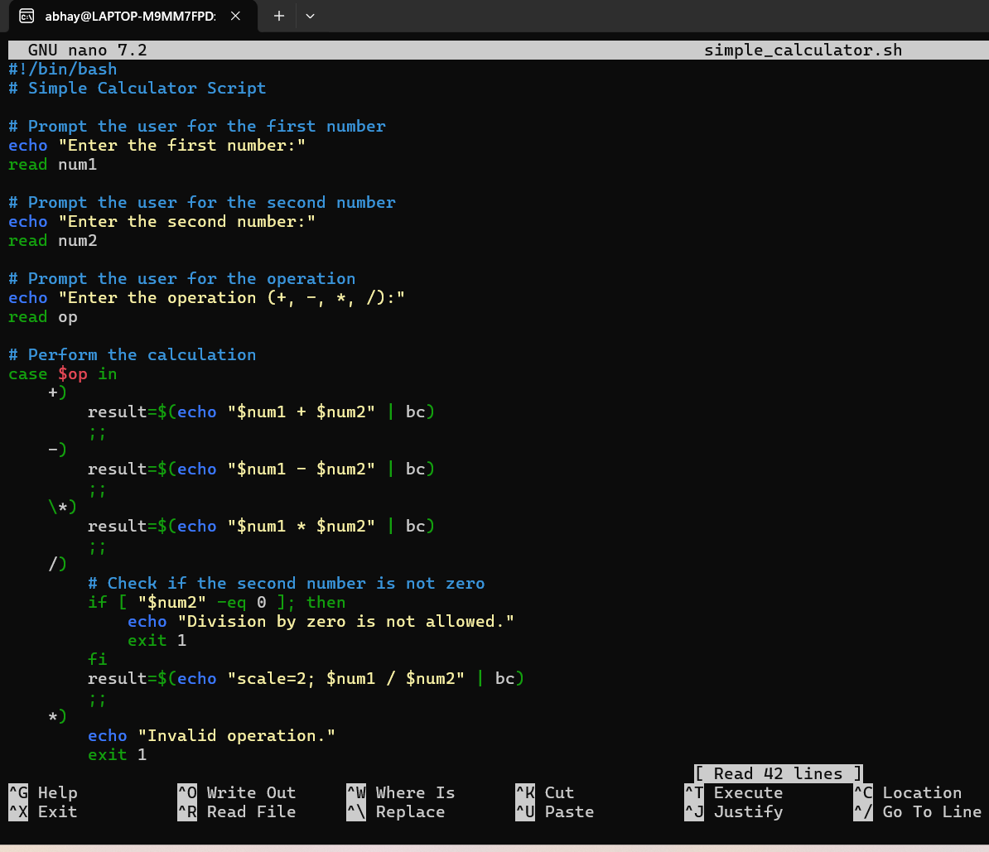

1. Make the script Executable: “chmod +x simple_calculator.sh”
2. Run the script:

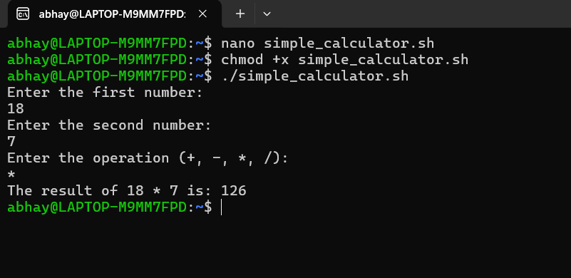

1. Enter first number and second number after that select the operator, press enter.